Screen grab taken from the video of this youtube video https://youtu.be/s9HV_jyeUDk?t=535
Code that was being used in his tradingview pinescript is as the screenshot below.
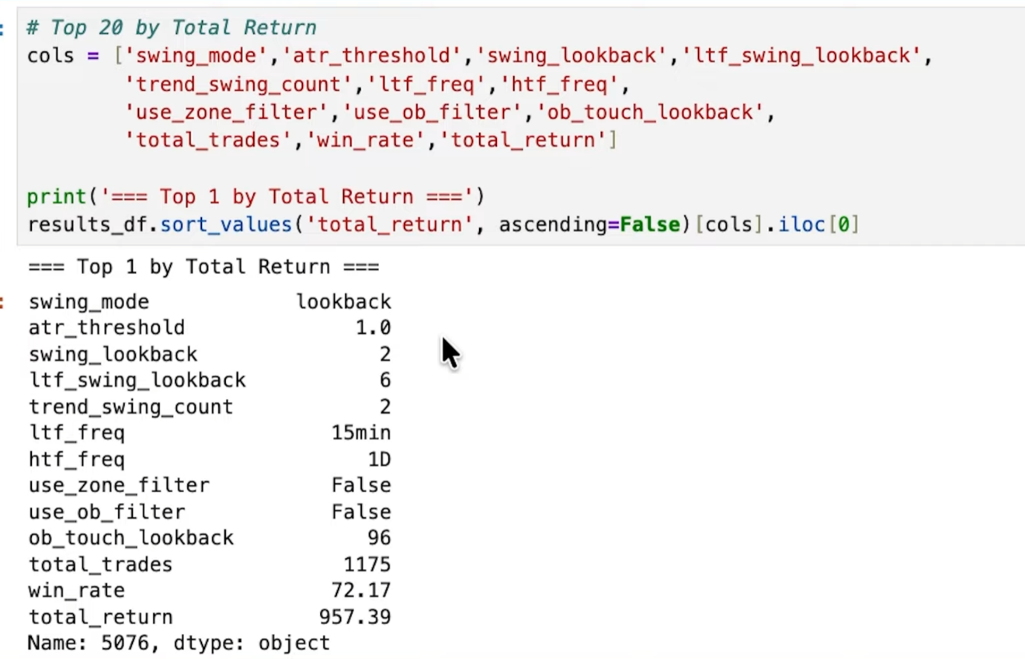
Best back tested strategy to find entry and recognize swing trades. Can experience up to 50% drawdown but most successful over long periods.

